## Tutorial 9-10 (Question 1, 2 and 3)

## Normalization – Dependency Diagram

* + 1. Using the INVOICE table structure shown in the table, draw its dependency diagram and identify all dependencies (including all partial and transitive dependencies). You can assume that the table does not contain repeating groups and that any invoice number may reference more than one product. You can also assume that any given product is supplied by a single vendor, but a vendor can supply many products. Therefore, it is proper to conclude that the following dependency exists:

PROD_NUM → PROD_DESCRIPTION, PROD_PRICE, VEND_CODE, VEND_NAME

(*Hint*: This table uses a composite primary key.)

Table 1 Sample INVOICE Records

|  |  |  |  |  |  |
| --- | --- | --- | --- | --- | --- |
| **Attribute Name** | **Sample Value** | **Sample Value** | **Sample Value** | **Sample Value** | **Sample Value** |
| INV_NUM | 211347 | 211347 | 211347 | 211348 | 211349 |
| PROD_NUM | AA-E3422QW | QD-300932X | RU-995748G | AA-E3422QW | GH-778345P |
| SALE_DATE | 15-Jan-2004 | 15-Jan-2004 | 15-Jan-2004 | 15-Jan-2004 | 16-Jan-2004 |
| PROD_DESCRIPTION | Rotary sander | 0.25-in. drill bit | Band saw | Rotary sander | Power drill |
| VEND_CODE | 211 | 211 | 309 | 211 | 157 |
| VEND_NAME | NeverFail, Inc. | NeverFail, Inc. | BeGood, Inc. | NeverFail, Inc. | ToughGo, Inc. |
| NUM_SOLD | 1 | 8 | 1 | 2 | 1 |
| PROD_PRICE | $49.95 | $3.45 | $39.99 | $49.95 | $87.75 |

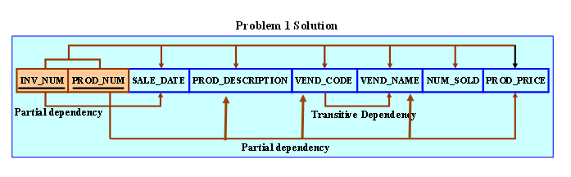

1NF (DBDL format) – *remove repeating groups*

**INVOICE (INV_NUM, PROD_NUM, SALE_DATE, PROD_DESCRIPTION, VEND_CODE, VEND_NAME, NUM_SOLD, PROD_PRICE)**

* + 1. Using the initial dependency diagram drawn in Problem 1, remove all partial dependencies, draw the new dependency diagrams, and identify the normal forms for each table structure you created.

(*Hint*: Your actions should produce three dependency diagrams.)

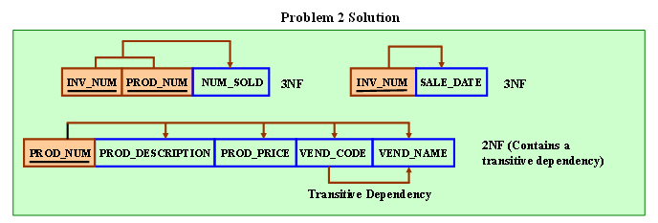

2NF (DBDL format) – *remove partial dependency*

**INV_PROD** **(INV_NUM*, PROD_NUM*, NUM_SOLD)**

**INVOICE (INV_NUM, SALE_DATE)**

**PRODUCT (PROD_NUM, PROD_DESCRIPTION, PROD_PRICE, VEND_CODE, VEND_NAME)**

* + 1. Using the table structures you created in Problem 2, remove all transitive dependencies, draw the new dependency diagrams, and identify the normal forms for each table structure you created.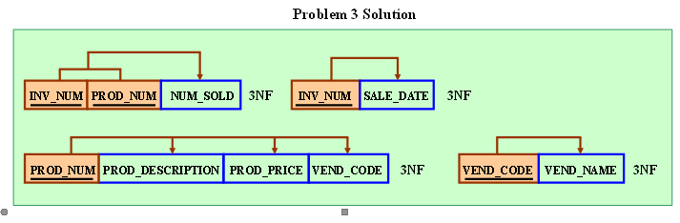

3NF (DBDL format) – *remove transitive dependency*

**INV_PROD** **(INV_NUM*, PROD_NUM*, NUM_SOLD)**

**INVOICE (INV_NUM, SALE_DATE)**

**PRODUCT (PROD_NUM, PROD_DESCRIPTION, PROD_PRICE, VEND_CODE*)**

**VENDOR (VEND_CODE, VEND_NAME)**